**A Web Portal for Industrial Visit Information and offering Confirmation System**

**Abstract:**

This project is entitled **“A Web Portal for Industrial Visit Information and offering Confirmation System”** is web based application developed by using the php as front end and MySql as back end.

In this web application fully provide Industrial Visit Information and offering Confirmation details. So this Website Company and student have to register this application. The role of company is to add Industrial Visit providing company details and also add Industrial Visit details like paid intern or non-paid intern. After that new student can register into this application and login by using the secure username and password. After successful login student can view company information and Industrial Visit details for using this web application. Student view Industrial Visit details and apply the Industrial Visit. The company authority can login and adds approval of the student’s Industrial Visit and duration of the visiting period and certificate details and all other details.

Once the admin give an Industrial Visit approval the confirmation alert sent to the student registered mail id. After completing this process the report will be generated.

**Software Description:**

**HARDWARE REQUIREMENT**

* **Processor** : Intel dual core
* **RAM**  : 2 GB
* **Hard Disk Drive** : 500 GB
* **Monitor**  : 17” Color Monitor

**SOFTWARE REQUIREMENT**

* **Front End/GUI Tool** : Macromedia Dream viewer
* **Operating System** : Windows Family Any(7,8,10)
* **Web Technology** : PHP
* **Application** : Web Application
* **Back End**  : My Sql

**EXISTING SYSTEM**

In the existing system student can directly visit to the company and request about the Industrial Visit purpose. It’s difficult to reach the each company visiting process and requesting process done manual by the student. The existing system is manual, doesn’t have the flexibility to maintain and send the Industrial Visit request and acceptance details. There are many possibilities for the mistake to take place when the searching or finalizing companies are made manually. The existing system is tedious and time consuming. It also requires handling knowledge and skilled manpower. The maintenance cost with this system is periodical and unavoidable.

**DISADVANTAGES**

* Manual work
* Storing and retrieving not easy
* No automatic messaging option available

**PROPOSED SYSTEM**

This proposed Web application system is designed in the favor of the college student, which helps them to get easy Industrial Visit approval intimation such as company name and Industrial Visit schedule information to their students through this web application .It proposes an effective way to communicate intimation to the students. Our proposed System Totally design to reduce the communication gap between companies and college students. Our proposed scheme is user friendly system can use efficient way .completely avoid manual process in our work. The proposed system has been designed to eliminate the major disadvantages of the existing system.

**ADVANTAGES**

* Systematic work
* Easy storing and retrieving
* No redundancy

**MODULES**

* **Authentication**
* **Company Register**
* **Student Register**
* **Student Industrial Visit Request**
* **Company Approval**
* **Feedback**
* **Report**

**MODULES DESCRIPTION**

**Authentication**

This is the major module of this web application, admin, student, company all are login into this application by using this module. Admin is the major role in this web application, and have a full authority to add, view, modify, and delete any records into this web application.

**Company Register**

This is fully based on the company control module. companies are ready to allow the students for visiting their company for educational wise students can improve their practical knowledge, companies are registered into this web application and generate their own secure username and password.

**Student register**

In this module college students can register into this application by using this module. These modules generate the unique id for each register students to avoid duplicate records from the database. Students can register through this module; this module contains the students profile such as name, gender, contact, email, address, college name, department, year and other basic details.

**Student Industrial Visit request**

After successful registration student can login into this application and type there required location name, based on the location this application will retrieve the list of company details and show to the students, based on the student’s interest they can choose any companies and send request to the company.

**Approve Request**

After viewing the student’s Industrial Visit request company side admin can add the response to the student reply, schedule the date and time, time duration and description about the Industrial Visit l procedure all the details company upload in this module, students can view from their page.

**Feedback**

After successful visit of the Industrial Visit company students can post their own opinion in this feedback form. Student’s feedback is useful to the companies and all other college school students to visit the company and get an practical knowledge about the Industrial Visit development work.

**Report**

The final module collects and generates the data into report format. The admin can view the number of companies register in this website, number of student’s participant this website, total visits and total registered users.

**DATA FLOW DIAGRAM**

The symbols appearing in the DFD has been explained below:

- Represents a process

- Which shows data flow

- Designation of the data

- Shows Data source

**DATA FLOW DIAGRAM**

**Level-0**

Send request

Login, view all details

Admin

Student

View Report and Result

Register /login

Company

Company sends approval

**Level-1**

If login successful

User id and password

Login table

**Admin**

Student Table

Company table

Request table

Request

Login failed

Response

Report

Approval table

View Approval

View company details

Admin view student details

Admin view request details

Admin view company details

Admin view approval details

Get Report

View request

View Student details

**Level 2**

If login successful

User id and password

Login table

**Company**

Company Table

Request table

Request

Login failed

Response

Report

Approval table

Store Approval

View request details

Add company details

Admin Give approval

Get Report

View request

Store company details

**Level 3**

If login successful

User id and password

Login table

**Student**

Student Table

Company table

Request table

Request

Login failed

Response

Approval table

View Approval

View company details

Student Register

Send request details

Student view company details

Student view approval details

Store request

Store Student details

**ER DIAGRAM**

Approval

Student

Company

Request

View

Send

C id

Approval

**1.INTRODUCTION**

Web based Student Industrial Visit Portal has been introduced as part of the curriculum for most of higher learning institutions worldwide. Its main purpose is to expose students to a real working environment and relate theoretical knowledge with applications in the industries. The objectives are to produce well-rounded graduates who possess technical competence, lifetime learning capacity, critical thinking, communication and behavioral skills, business acumen, practical aptitude and solution synthesis ability. Issues such as, long distance learning, communication, monitoring and management arise as crucial to ensure the success of the program. The main objective of this project is to develop a prototype of Student Industrial Industrial Visit Web Portal that automates current manual processes to reduce possible problems in communication, data loss and redundancy. It makes monitoring, instructor assignment and scheduling, grading and reporting easy and to greater extent, error free. Student Industrial Visit Portal responsible in Industrial Visit processes from student application, checking students’ eligibility status, Industrial Visit placement application and confirmation, lecturer visit scheduling, and grading. Many problems arise since all processes are still been done manually, such as data missing and redundancy, delay in grading process, communication problems and most crucial is student monitoring. Currently, telephone and email are the main methods of communication which have imposed many problems such as update to all students has to be approached individually and resulted in high cost of communications.

**TABLE DESIGN**

Login table

|  |  |  |  |  |
| --- | --- | --- | --- | --- |
| S.No | Colum Name | Data Type | Description | Constraint |
| 1 | Username | Varchar(20) | Contains login username | Not null |
| 2 | Password | Varchar(20) | Contains login password | Not null |
| 3 | Usertype | Varchar(20) | Contains login user type | Not null |

Register table

|  |  |  |  |  |
| --- | --- | --- | --- | --- |
| S.No | Colum Name | Data Type | Description | Constraint |
| 1 | Register ID | Integer | Contains student register number | Primary key |
| 2 | Student name | Varchar(20) | Contains student name | Not null |
| 3 | Gender | Varchar(10) | Contains student gender | Not null |
| 4 | Department | Varchar(20) | Contains student department | Not null |
| 5 | Semester | Varchar(10) | Contains student semester | Not null |
| 6 | Class | Varchar(10) | Contains student class | Not null |
| 7 | Register type | Varchar(10) | Contains register type | Not null |
| 8 | Contact number | Integer | Contains contact number | Not null |
| 9 | Email id | Varchar(50) | Contains student email id | Not null |
| 10 | Address | Varchar(100) | Contains student address | Not null |

Company Profile

Primary key: company id

|  |  |  |  |  |
| --- | --- | --- | --- | --- |
| S.No | Colum Name | Data Type | Description | Constraint |
| 1 | Company ID | Integer | Contains company id | Primary key |
| 2 | Company name | Varchar(20) | Contains company name | Not null |
| 3 | Company type | Varchar(10) | Contains company type | Not null |
| 4 | Website | Varchar(10) | Contains company website | Not null |
| 5 | Contact | Integer | Contains company contact | Not null |
| 6 | Email id | Varchar(20) | Contains company email id | Not null |
| 7 | Hr name | Varchar(20) | Contains hr name | Not null |
| 8 | Hr contact | Integer | Contains hr contact | Not null |
| 9 | Branch details | Varchar(20) | Contains branch name | Not null |

Intern Request Table

|  |  |  |  |  |
| --- | --- | --- | --- | --- |
| S.No | Colum Name | Data Type | Description | Constraint |
| 1 | Request id | Integer | Contains request id | Primary key |
| 2 | Student id | Varchar(10) | Contains student id | Not null |
| 3 | Student name | Varchar(20) | Contains student name | Not null |
| 4 | College name | Varchar(20) | Contains college name | Not null |
| 5 | College type | Varchar(20) | Contains the college type | Not null |
| 6 | Intern date | Datetime | Contains intern request date | Not null |
| 7 | Staf name | Varchar(20) | Contains staff name | Not null |
| 8 | Total members | Integer | Contains total students count | Not null |
| 9 | Company name | Varchar(20) | Contains the student selected company | Not null |

Industrial Visit approval table

|  |  |  |  |  |
| --- | --- | --- | --- | --- |
| S.No | Colum Name | Data Type | Description | Constraint |
| 1 | Request date | Date time | Contains request date time | Not null |
| 2 | College name | Varchar(20) | Contains college name | Not null |
| 3 | Department | Varchar(20) | Contains department name | Not null |
| 4 | Total students | Integer | Contains total student count | Not null |
| 5 | Branch name | Varchar(20) | Contains branch name | Not null |
| 6 | Confirm date | Date time | Contains confirm date | Not null |
| 7 | Inchargename | Varchar(20) | Contains incharge name | Not null |
| 8 | Total days | Integer | Contains total approved days | Not null |

Feedback table

|  |  |  |  |  |
| --- | --- | --- | --- | --- |
| S.No | Colum Name | Data Type | Description | Constraint |
| 1 | Feedback date | Date time | Contains feedback date time | Not null |
| 2 | Student id | Integer | Contains student id | Not null |
| 3 | College name | Varchar(20) | Contains college name | Not null |
| 4 | College type | Varchar(20) | Contains college type | Not null |
| 5 | Feedback | Varchar(Max) | Contains feedback description | Not null |
| 6 | reply date | Datetime | Contains feedback reply date | Not null |

**4. FEASIBILITY STUDY**

A system is a feasible system only if it is feasible within limited recourse and time. In this system each and every process can be feasible for the user and also developer. It proved user friendly input such as device independent inputs and getting proper solution for the problem.

The different types of feasible system that have to analyze are,

* + - **Technical Feasibility**
    - **Behavioral Feasibility**
    - **Economical Feasibility**
    - **Operational Feasibility**

**4.1 Technical Feasibility**

Technical Feasibility is the assessment of the technical view of the system. The system is developed for Dot net environment; a platform independent tool is used to develop the system.

The consideration those are normally associated with the technical feasibility include the following

* Development risk
* Resource availability
* Technology

The development risk concerns the probability, the function of all elements and its performance should be same in all platforms and in the system that is being developed. This system is developed according to the standards and the development software tools are selected in such a way to avoid the problems cited above.

The software used to develop this system is Windows XP, visual studio Dot net is done efficiently, and the concept of SQL helps to create the application backend. These components are also helpful in providing interactivity to Java applications.

**4.2 Behavioral Feasibility**

It is common knowledge that computers illustrations have something to do with turnover transfers, retraining and changes in user or developer status. The main emphasis is customer service, personal contacts with customers.

Feasibility report is directed towards management. It evaluates the impact of the proposed changes on the area in question. The report is a formal document for management use, brief enough and sufficiently non-technical to be understood.

**4.3 Economical Feasibility**

Economic feasibility or cost benefit is an assessment of the economic justification for a computer based system project. Though this system the administrator can use the tool from anywhere within their concern. The system is developed using the existing resources. So the project is economically feasible.

This is the most frequently used method for evaluating the effectiveness of a user system. More commonly, know as cost analysis the procedure is to determine the benefits and savings that are expected from a candidate system and compare them with costs.

This system getting hundreds present economical feasibility. It will be achieved goal very efficiently. And evolution of development cost (hardware and software needed) is weighted against the ultimate income or benefit derived from the system. Finally, it is assured that this project is economically feasible

**4.4 Operational Feasibility:**

Operational Feasibility deals with the study of prospects of the system. This system operationally eliminates all the tensions of the administrator and helps in effectively tracking the project progress. This kind of automation will surely reduce the time and energy, which previously consumed in manual work. Based on the study, the system proved to be operationally feasible.

**SYSTEM DESIGN**

Systems design is the process of defining the architecture, modules, interfaces, and data for a system to satisfy specified requirements. Systems design could be seen as the application of systems theory to product development.

**6.1 FILE DESIGN**

The file system is used to control how data is stored and retrieved. Without a file system, information placed in a storage area would be one large body of data with no way to tell where one piece of information stops and the next begins. By separating the data into individual pieces, and giving each piece a name, the information is easily separated and identified. Taking its name from the way paper-based information systems are named, each group of data is called a file. The structure and logic rules used to manage the groups of information and their names are called a "file system”. There are many different kinds of file systems. Each one has different structure and logic, properties of speed, flexibility, security, size and more. Some file systems have been designed to be used for specific applications

**6.2 INPUT DESIGN**

Input Design converts the user-oriented inputs to computer-based formats. Inaccurate input data are the most common cause of errors in data processing. Error data entered by the data operator can be controlled by the input design. The goal of designing input is to make the data entry easy, logical and as free from errors as much as possible.

The proposed system is completely menu-driven. It is a powerful tool for interactive design. It helps the user comprehend the range of alternatives available and also prevents them from making an invalid selection. All entry screens are interactive in nature. It has been designed taking into account all the constraints of the end-user.

**Some other features included are:**

* The form title clearly states the purpose of the form
* Adequate space is given for data entry

Data Validation is done for eliminating duplicate entries

**6.3 OUTPUT DESIGN**

Outputs are the most important and direct source of information to the customer and management. Intelligent output design will improve the system's relationship with the user and help in decision making. Outputs are used to make permanent hard copy of the results for later consultation. The output generated by the system is often regarded as the criteria for evaluating the performance of the system. The output design was based on the following factors.

* Usefulness determining the various outputs to be printed to the system user.
* Differentiating between the outputs to be displayed and those to be printed.
* The format for the presentation of the output.

For the proposed system, it is necessary that the output should be compatible with the existing manual reports. The outputs have been formatted with this consideration in mind. The outputs are obtained after all the phase, from the system can be displayed or can be produced in the hard copy. The hard copy is highly preferred since it can be used by the controller section for future reference and it can be used for maintaining the record.

**6.4 DATABASE DESIGN**

The general theme behind a database is to handle information in an integrated manner. There is none of the artificiality that is normally embedded in separate files or applications. A database is collection of interrelated data stored with minimum redundancy to serve many users quickly and efficiently. The general objective is to make information access easy, quick, inexpensive and flexible for the user.

In a database environment, common data are available which several authorized users can use. The concept behind a database is an integrated collection of data and provides a centralized access to the data from the program. It makes possible to treat data as a separate resource.

While designing database, several objectives must be considered:

* Controlled redundancy
* Data Independence
* More information at low cost
* Accuracy and Integrity
* Recovery from failure
* Privacy and security
* Performance

**Steps for Table Design**

* State what kind of information we need to handle to get the desired output.
* Find out what information is needed for fields (i.e.) field type, size etc.
* Remove any data items, which is redundant.
* Table have one to one relationship needs a primary key field.
* Tables have one to many relationship needs to add a foreign key field to the table to match the primary key field table

**6.5 CODE DESIGN:**

Code is an ordered collection of symbols designed to provide unique identification of an attribute. Codes can be used for various purposes. They can specify object’s physical or performance characteristics and they can be used to give operational instructions. They also can show inter relationships and may sometimes used to achieve secrecy or confidentiality. Codes are designed for optimum human-oriented use and machine efficiency. Codes posses uniqueness, expandability, conciseness, uniform nets, simplicity, versatility, sort ability, meaningfulness and operability.

Sufficient effort and time is spent in the preliminary study of the problem to design an efficient code. Activate serve scripting is object oriented. The source code is designed so that it can do transaction efficiently. It is the code that dose all the updating, modifications, etc. for all object used in the project there exist an associated source code, which explains the work of that object. It also describes the flow of the project.

Source code is enhanced by structured coding techniques by good internal comments and features provided by the language.

The code design in this project is made modular. The modular behavior enables easy debugging and testing. Inserting comment statement wherever enhances the coding. This is done during the documentation process coding is done in such a way that errors can be trapped easily. Also modifications can easily be appended due to the codes modular behavior

**SYSTEM TESTING AND MAINTENANCE**

**Objectives of Testing**

Software testing is a critical element of software quality assurance that represents the ultimate review of specifications, design and coding. The user tests the developed system and changes are made according to their needs. The testing phase involves the testing of developed system using various kinds of data. It involves user training, system testing and successful running of the developed system.

The changes are made according to their needs. The testing phase involves the testing of the developed system using various kinds of data. While testing, errors are noted and corrections are made system testing is the stage of implementation, which is aimed at ensuring that the system works accurately and efficiently before live operation commences. The candidate system is subject to a variety of test: stress recovery, and security and usability tests.

**Test Plan**

Testing is the process of executing a program with the intent of finding any errors. A good test of course has the high probability of finding a yet undiscovered error. A successful testing is the one that uncovers a yet undiscovered error.

A test is vital to the success of the system; system test makes a logical assumption that if all parts of the system are correct, then goal will be successfully achieved. The candidate system is subjected to a verity of tests online like responsiveness, its value, stress and security. A series of tests are performed before the system is ready for user acceptance testing.

**Testing Methods**

The different types of testing are:-

* **Unit Testing**
* **Integration Testing**
* **Validation Testing**
* **Output Testing**

**UNIT TESTING**

Unit testing focuses verification efforts on the smallest unit of software design, the module. This is also known as “Module Testing” The modules are tested separately this testing is carried out during programming stage itself. In this step each module is found to be working satisfaction as regard to the expected output from the module.

**INTEGRATION TESTING**

Integration testing focuses on the design and construction of the software architecture. Data can be lost across an interface, one module can have adverse effect on another sub functions and show on. Thus integration testing is a systematic technique for constructing test to uncover errors associated with in the interface. In this project, all the modules are companied and then the entire program is tested as a whole.

**VALIDATION TESTING**

Validation testing is the requirement established as a part of software requirement analysis is validated against the software that has been constructed. This test provides the final assurance whether the software needs all functional, behavioral and performance requirements

Thus the proposed system under consideration has been tested by using validation testing and found to be working satisfactory.

**OUTPUT TESTING**

After performing the validation testing, the next step is the output testing of the proposed system, since no system could be useful if it does not produce required output in the specific format. Tested asking the users about the format required by them, the output is considered into two ways: one is on the screen and the other is printed format.

The output format on the screen is found to be correct as the format designed according to the user needs, for the hard copy also, the output comes as specified by the user. Hence output testing does not result in correction in the system.

**SYSTEM IMPLEMENTATION**

Implementation is the stage where the theoretical design is turned into a working system. The most crucial stage in achieving a new successful system and in giving confidence on the new system for the users that it will work efficiently and effectively. The system can be implemented only after thorough testing is done and if it is found to work according to the specification. It involves careful planning, investigation of the current system and its constraints on implementation, design of methods to achieve the change over and an evaluation of change over methods a part from planning. Two major tasks of preparing the implementation are education and training of the users and testing of the system.

The more complex the system being implemented, the more involved will be the systems analysis and design effort required just for implementation. The implementation phase comprises of several activities. The required hardware and software acquisition is carried out. The system may require some software to be developed. The web based application is implemented in PHP as front end MySQL as back end.

**System Maintenance:**

The maintenance plan specifies the scheduled servicing tasks and intervals (preventive maintenance) and the unscheduled servicing tasks (adaptive or corrective maintenance). Tasks in the maintenance plan are allocated to the various maintenance agencies. A maintenance allocation chart is developed to tag the maintenance tasks to the appropriate maintenance agencies. These include: in-service or in-house work centers, approved contractors, affiliated maintenance or repair facilities, original equipment manufacturer, etc. The maintenance plan also establishes the requirements for the support resources.

Related activities such as resource planning, budgeting, performance monitoring, upgrades, longer term supportability, and sustenance also need to be managed. These activities are being planned, managed, and executed over a longer time horizon and they concern the well being of the system over the entire life cycle.

**Front end tool:**

**ABOUT WINDOWS FAMILY**

The Windows experience operating system is available as home and professional edition and are similar suitable for the use on standalone computers. The home edition is suitable for user which worked with Windows 9x/ME till now and don't need special network or security features in their environment. If the users have used Windows NT/2000 private, in business or both, the Professional Edition is not only with a view of the administration optimally. Microsoft already encloses 10,000 drivers on the installation media of Windows XP; about the Windows update furthermore 2,000 drivers are available. The Professional Edition of Windows XP has more network features than the **Home Edition**. An update of Windows 9 x/ME is possible, with Windows NT/2000 only the Professional Edition can be used for update. Optional FAT32 and NTFS are available as the file system for the installation partition. Windows XP (Windows version 5.1) becomes a predecessor of Windows 9x/ME as well as Windows NT/2000 and is available for 32-bits CPUs in the following versions:

* Embedded
* Home Edition (1 CPU) for private user (Oct. 2001)
* Professional Edition (2 CPU) for business user (Oct. 2001)
* Media Center (1 CPU) especially for multimedia devices (Nov. 2002)
* Tablet PC Edition especially for Tablet PCs (Nov. 2002)
* Server Edition (4 CPU)
* Advanced Server (8 CPU), also 64-bit Intel CPUs

A **64-bit version** of Windows XP was announced officially of Microsoft in April 2003. The RC2 was available in February 2005. Windows XP Professional x64 was published in April 2005. At most 16 gbyte RAM are utilizable with that, the virtual address range enlarges to 16 tbyte. Same will be the **product activation** at all versions, which is needed at every new installation or extensive upgrade of the PC devices. As the most visual innovation the revised Windows interface with the new design is well done, the design called Luna (as of beta 2428) can display window elements in high colour. The return to the interface as of Windows 2000 is further possible. The representation and organization of the central registry is quit the same as used in Windows 2000.

**FEATURES:**

* Fast user switching
* Network assistant
* Remote control for the diagnosis (Remote assistant)
* Simplified user interface
* Windows Media Player
* Internet Explorer 6.0
* Windows Movie Maker

The graphic device interface (GDI) in the version GDI+ can take advance of gamma correction and 3D interfaces in high color depth. Windows XP is more based on HTML than previous versions. The system control was designed complete in HTML. With the new CD-R/CD-RW software. It is it is possible to create easy and simple CDs. The Windows terminal service makes the access to shared Windows XP desktop with an terminal client like the VNC solution.

The **Service Pack 2** (SP2) for Windows XP needs about 900 mbyte of free storage space. Another system modification is the Security Center, which shows the status and settings of the firewall, automatic updates and one additional anti virus program. The new memory function "data execution prevention" protects software code in the memory in front of manipulation like the insert of malicious program code to be executed, the protection works only with 64-bit processors. The improved firewall now can detect waiting ports for connections and the definition of exception rules for various network services.   
  
 The browser was extended by a pop-up blocker; the file execution protection with information about the used download zone was revised generally. Downloaded programs inherit the zone information of the browser and warn before the execution from Internet files as well as with the NTFS file system also before executing on local partitions.   
  
 Versions are,

1. Service Pack1
2. Service Pack2
3. Service Pack3

**PHP**: Hypertext Preprocessor is a widely used, general-purpose scripting language that was originally designed for web development to produce dynamic web pages. For this purpose, PHP code is embedded into the html source document and interpreted by a web server with a PHP processor module, which generates the web page document. As a general-purpose programming language, PHP code is processed by an interpreter application in command-line mode performing desired operating system operations and producing program output on its standard output channel. It may also function as a graphical application. PHP is available as a processor for most modern web servers and as a standalone interpreter on most operating systems and computing platforms.

PHP was originally created by rasmus lerdorf in 1995 and has been in continuous development ever since. The main implementation of PHP is now produced by the PHP group and serves as the de facto standard for PHP as there is no formal specification. PHP is free software released under the PHP license.

Basic object-oriented programming functionality was added in php 3 and improved in PHP; object handling was completely rewritten for PHP5, expanding the feature ser and enhancing performance. In previous versions of PHP, objects were handled like value types. The drawback of this method was that the whole object was copied when a variable was assigned or passed as a parameter to a method. In the new approach, objects are referenced by handle, and not by value.

PHP 5 introduced private and protected member variables and methods, along with abstract classes and final classes as well as abstract methods and final methods. It also introduced a standard way of declaring constructors and destructors, similar to that of other object-oriented languages such as c++, and a standard exception handling model.

PHP is widely-used general-purpose scripting languages that is especially suited for Web development and can be embedded into HTML.PHP files contain PHP scripts and HTML.PHP files have the extension “php”, “php3”, “php4”, or “phtml”.

**Using PHP**

* Generate dynamic web papes.PHP can display different content to different user or display different content at different times of the day.
* Process the contents of HTML forms. We can use a PHP to retrieve and respond to the data entered into an HTML form.
* Can create database-driven web pages. A PHP can insert new data or retrieve existing data from a database such a MySQL.

**Working of PHP**

PHP is a standard HTML file that is extended with additional features. Like a standard HTML file, PHP contains HTML tag that can be interpreted and displayed by a web browser. Anything we could normally place in an HTML file PHP applets, Blinking text, server side scripts. We can place in PHP. However, PHP has three important features that make it unique.

* PHP contains server side scripts.
* PHP provides several built-in objects.

**Hypertext Markup Language (HTML)**

HTML is an application of the Standard Generalized Markup Language (SGML), which was approved as an international standard in the year 1986. SGML provides a way to encode hyper documents so they can be interchanged. SGML is also a Meta language for formally describing document markup system. Infact HTML uses SGML to define a language that describes a WWW hyper document’s structure and inter connectivity.

**OVERVIEW OF BACK-END TOOL:**

**MYSQL-PHP MYADMIN:**

A database is a collection of interrelated data stored with minimum redundancy to serve many users quickly and efficiently. The general objective of database design is to make the data access easy, inexpensive and flexible to the user. With new tools approaches and available, the applications can be built that more closely match the needs and work habits of the business. MySQL will automatically read this information when you are using the MySQL interface or system commands (at the UNIX prompt), but not when connecting to the MySQL database from within a Perl script (see later). This means you do not need to specify when executing commands. For the rest of this document the commands will be written as if this file is in place. If it is not you will need to add the -u parameters to the command line.

PhpMyAdmin is a free software tool written in PHP intended to handle the administration of MySQL over the World Wide Web. PhpMyAdmin supports a wide range of operations with MySQL. The most frequently used operations are supported by the user interface (managing databases, tables, fields, relations, indexes, users, permissions, etc),while you still have the ability to directly execute any SQL statement.

PhpMyAdmin comes with a wide range of documentation and users are welcome to update our wiki pages to share ideas and howtos for various operations. The PhpMyAdmin team will try to help you if you face any problem, you can use variety of support channels to get help. PhpMyAdmin is also very deeply documented in a book written by one of developers - mastering PhpMyAdmin for effective MySQL management, which is available in English, Czech, German and Spanish. To ease usage to a wide range of people, PhpMyAdmin is translated into 62 languages and supports both LTR and RTL languages.

Since version 3.0.0 PhpMyAdmin joined the Gophp5 initiative and dropped compatibility code for older PHP and MySQL versions, version 3 and later requires at least PHP 5.2 and MySQL 5. To use with older PHP or MySQL versions, use the older (but still maintained) branch of 2.x releases, which you can find on the download page. PhpMyAdmin has won several awards. Among others, it was chosen as the best PHP.

MySQL server is a powerful database management system and the user can create application that requires little or no programming. It supports GUI features and an entire programming language, Phpmyadmin which can be used to develop richer and more developed application.

MySQL is a relational database, a database that stores information about related objects. In MySQL that database means a collection of tables that hold data. It collectively stores all the other related objects such as queries, forms and reports that are used to implement function effectively.

The MySQL database can act as a back end database for PHP as affront end, MySQL supports the user with its powerful database management functions MySQL however is a relational database, which means that you can define relationships among the data it contains. Relational database, are superior to flat file databases because you can store discrete information.

**Features:**

* Intuitive web interface.
* Support for most MySQL features.
* Browse and drop databases, tables, views, fields and indexes
* Create, copy, drop, rename and alter database, tables, fields, and indexes
* Maintenance server, databases and tables, with proposals on server configuration
* Execute, edit and bookmark any SQL-statement, even batch-queries.
* Manage MySQL users and privileges
* Manage stored procedures and triggers

**BIBLIOGRAPHY**

* Advanced PHP for Flash by Steve Webster, et al .friends of ED. Paperback- September 2002.
* Advanced PHP for Web Development (The Prentice Hall PTR Advanced Web Development Series) by Christopher Cosentino.Prentice Hall PTR. Paperback- 1 October, 2002.
* Advanced PHP Programming by Schlossnagle.Sams. Paperback- October 2003.
* A Programmer's Introduction to PHP by W.J. Gilmore.Apress. Paperback- 1 January, 2001
* Beginning PHP 4 Databases by Deepak Thomas, et al .Wrox Press Ltd. Paperback- 17 October, 2002.
* Beginning PHP4 Programming by John Blank, et al .Wrox Press Ltd. Paperback- 30 October, 2000
* Beginning PHP, MySQL and Apache. Wrox Press Ltd. Paperback- 1 June, 2003.
* Building a PHP Intranet Problem Design Solution by Wrox Author Team.WROX P.. Paperback- 31 December, 2004.

Building Database Applications on the Web Using PHP3 by Craig Hilton, Jeff Willis.Addison Wesley. Paperback- December 1999

**12. SCOPE OF FUTURE DEVELOPMENT**

Every application has its own merits and demerits. The project has covered almost all the requirements. Further requirements and improvements can easily be done since the coding is mainly structured or modular in nature. Changing the existing modules or adding new modules can append improvements. Further enhancements can be made to the application in android application, so that the system will be immediately sent notification to student when ever new Industrial Visit will upload. Student can upload Industrial Visit easy and effectively.

**CONCLUSION**

It is concluded that the application works well and satisfy the needs. The application is tested very well and errors are properly debugged. It also acts as the sharing of files to the valuable resources.. The application was tested very well and the errors were properly debugged. Testing also concluded that the performance of the system is satisfactory. All the necessary output is generated. This system thus provides an easy way to automate all the functionalities of consumption. If this application is implemented in little consumption, it will be helpful. Further enhancements can be made to the project, so that the website functions in a very attractive and useful manner than the present one. It is concluded that the application works well and satisfy the needs. The application is tested very well and errors are properly debugged. It also acts as the sharing of files to the valuable resources.

**Screens**

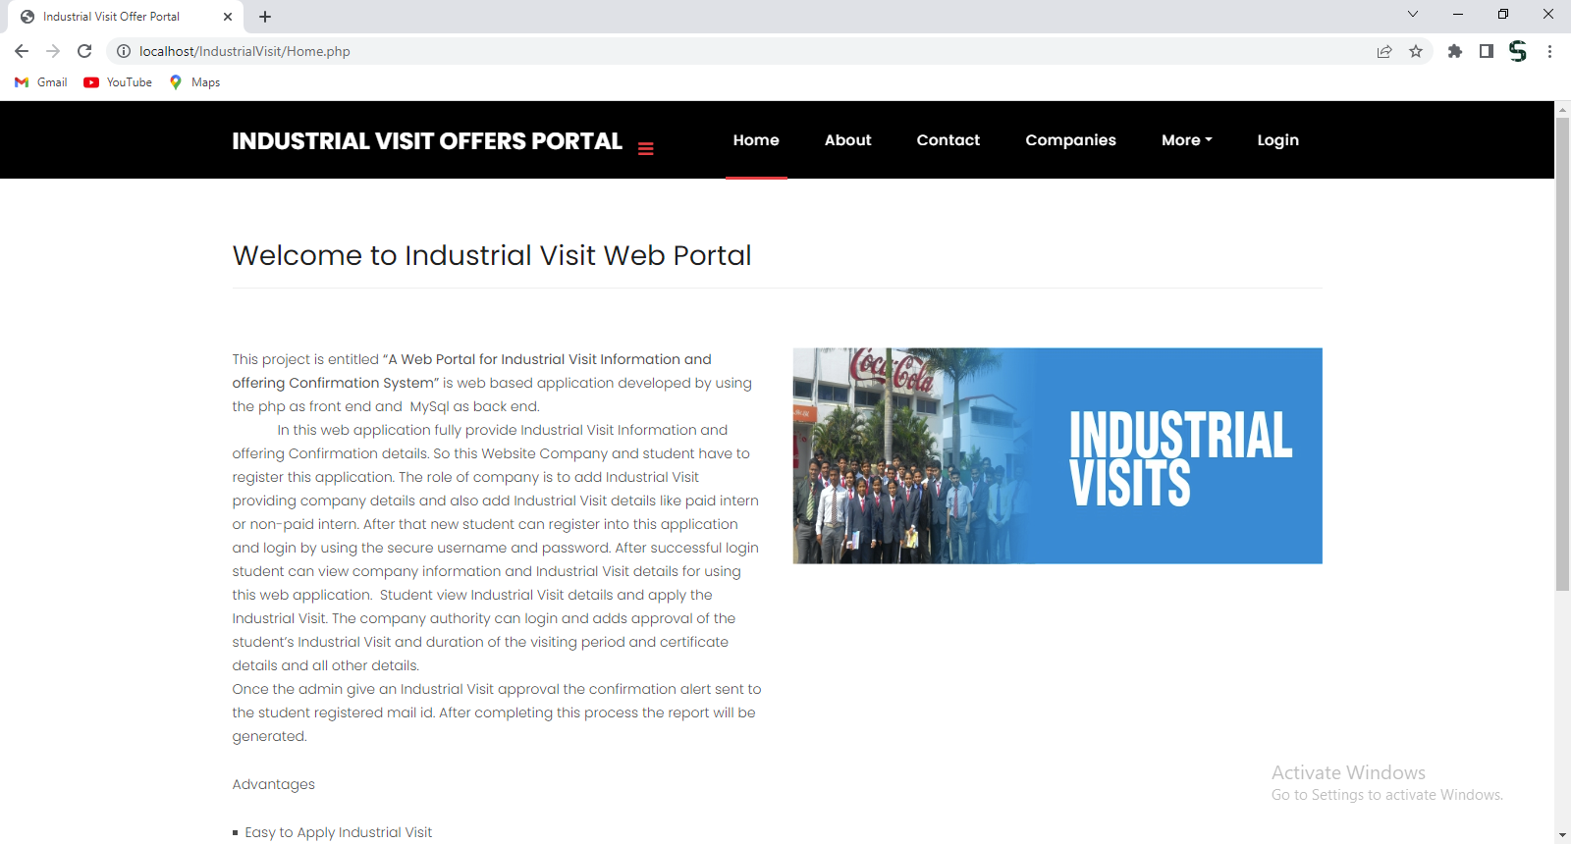

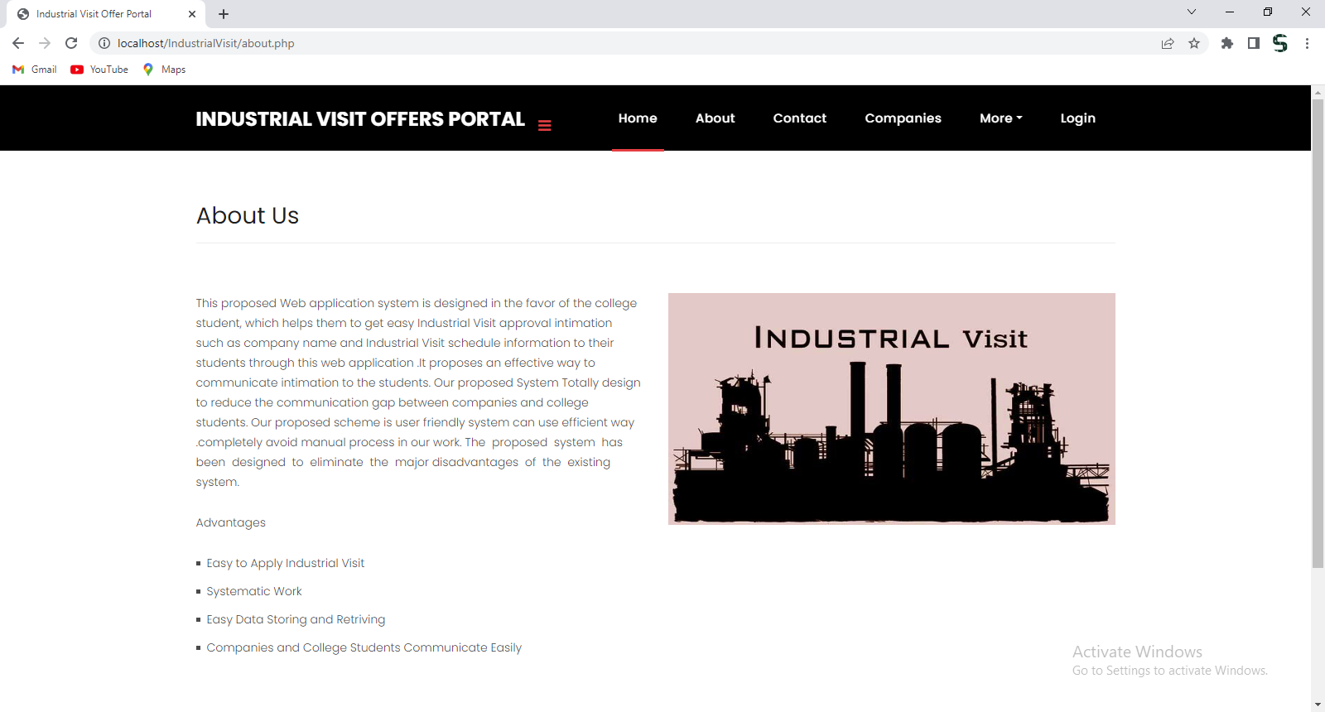

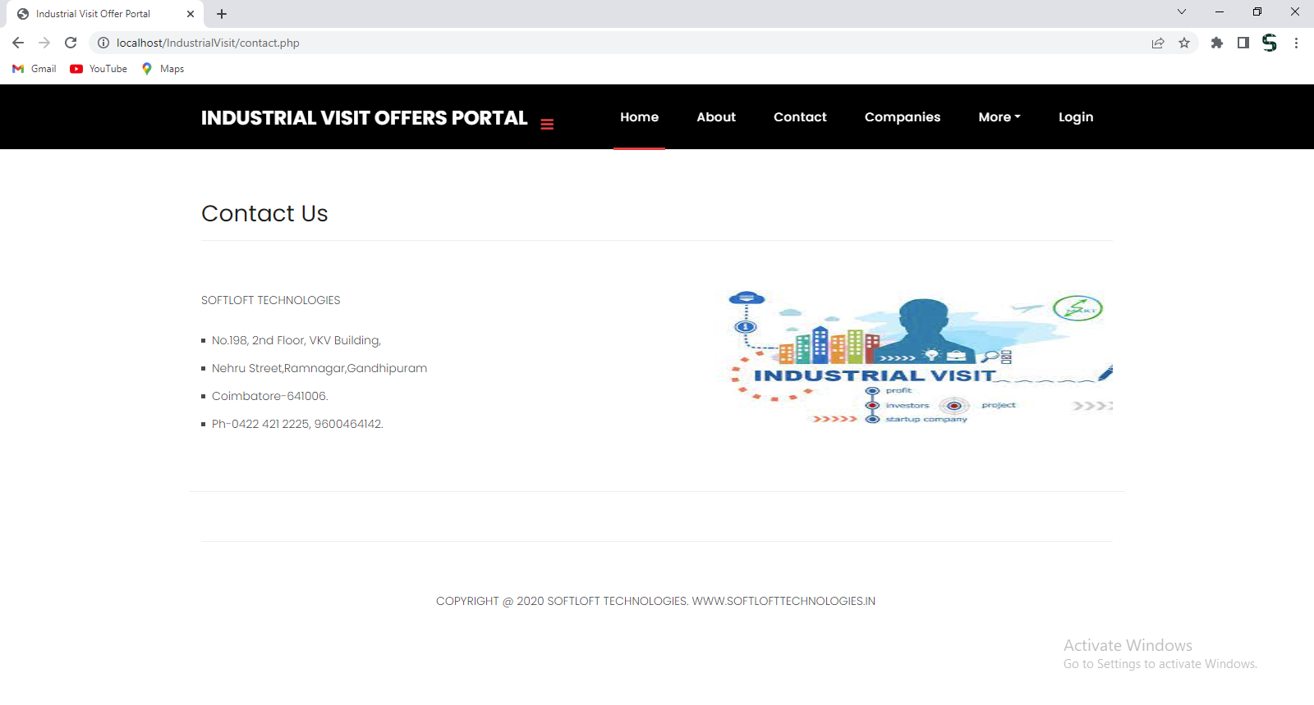

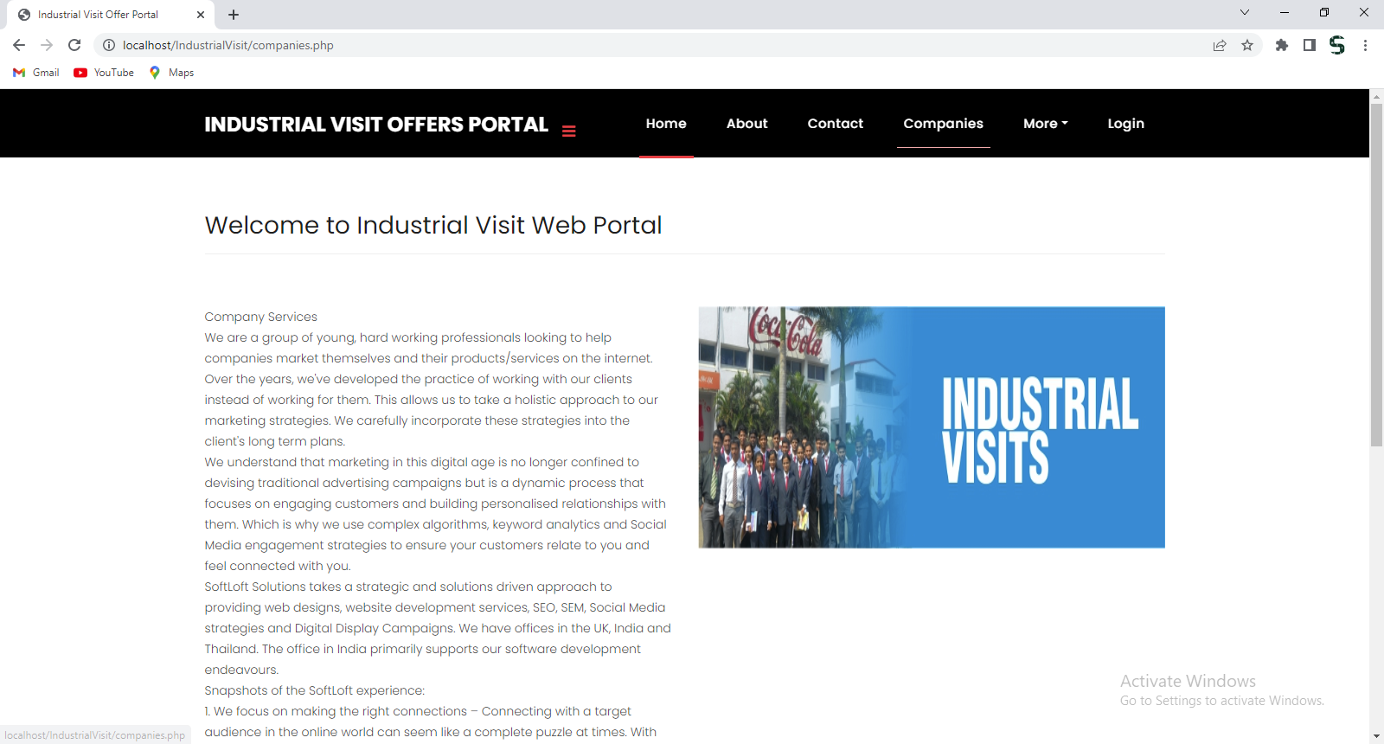

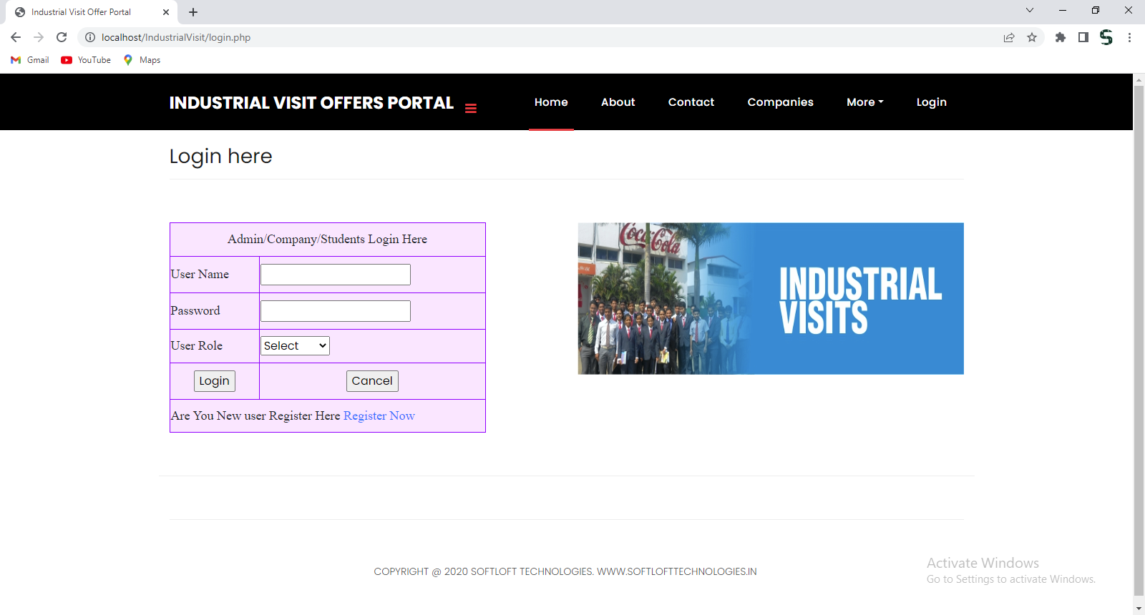

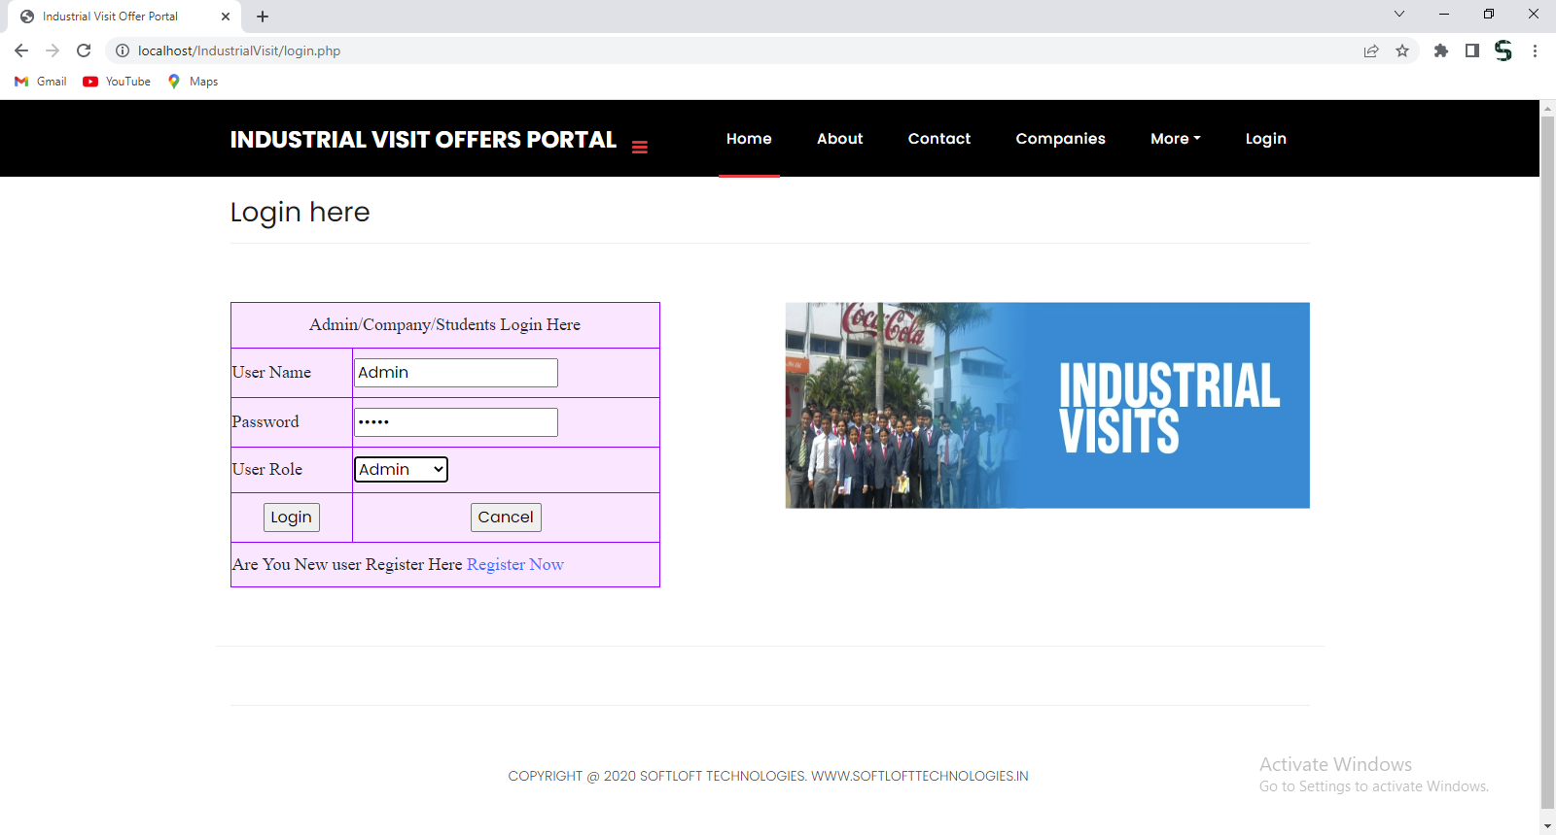

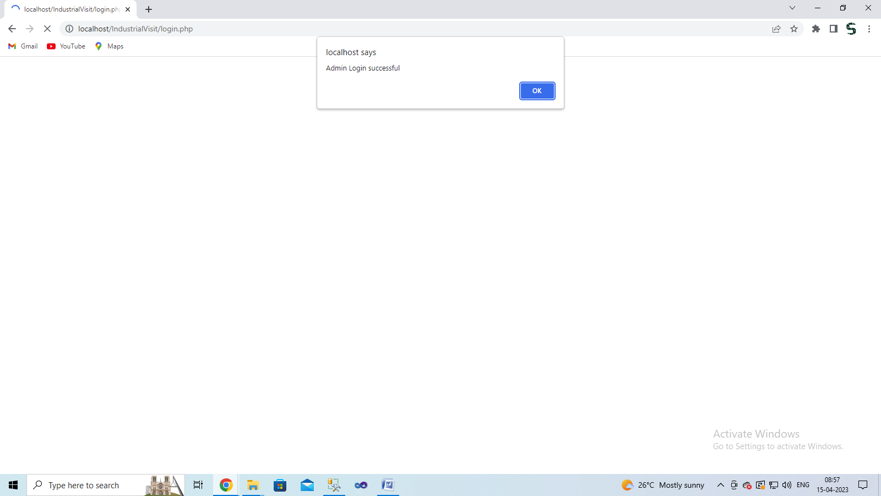

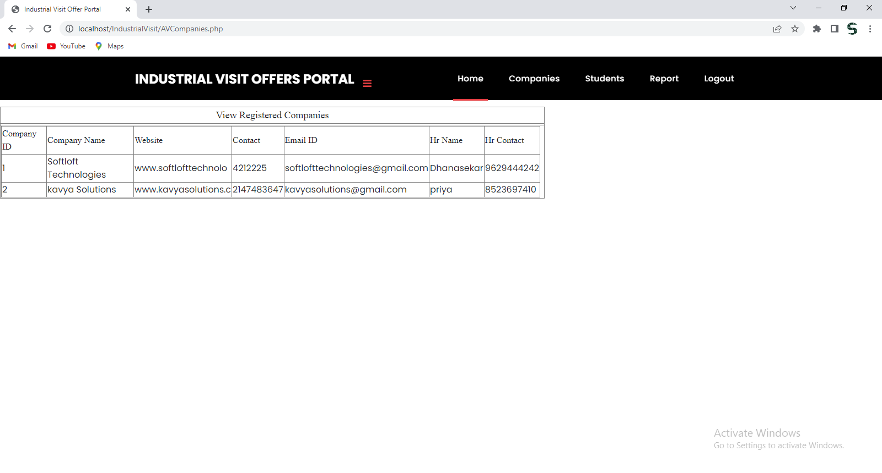

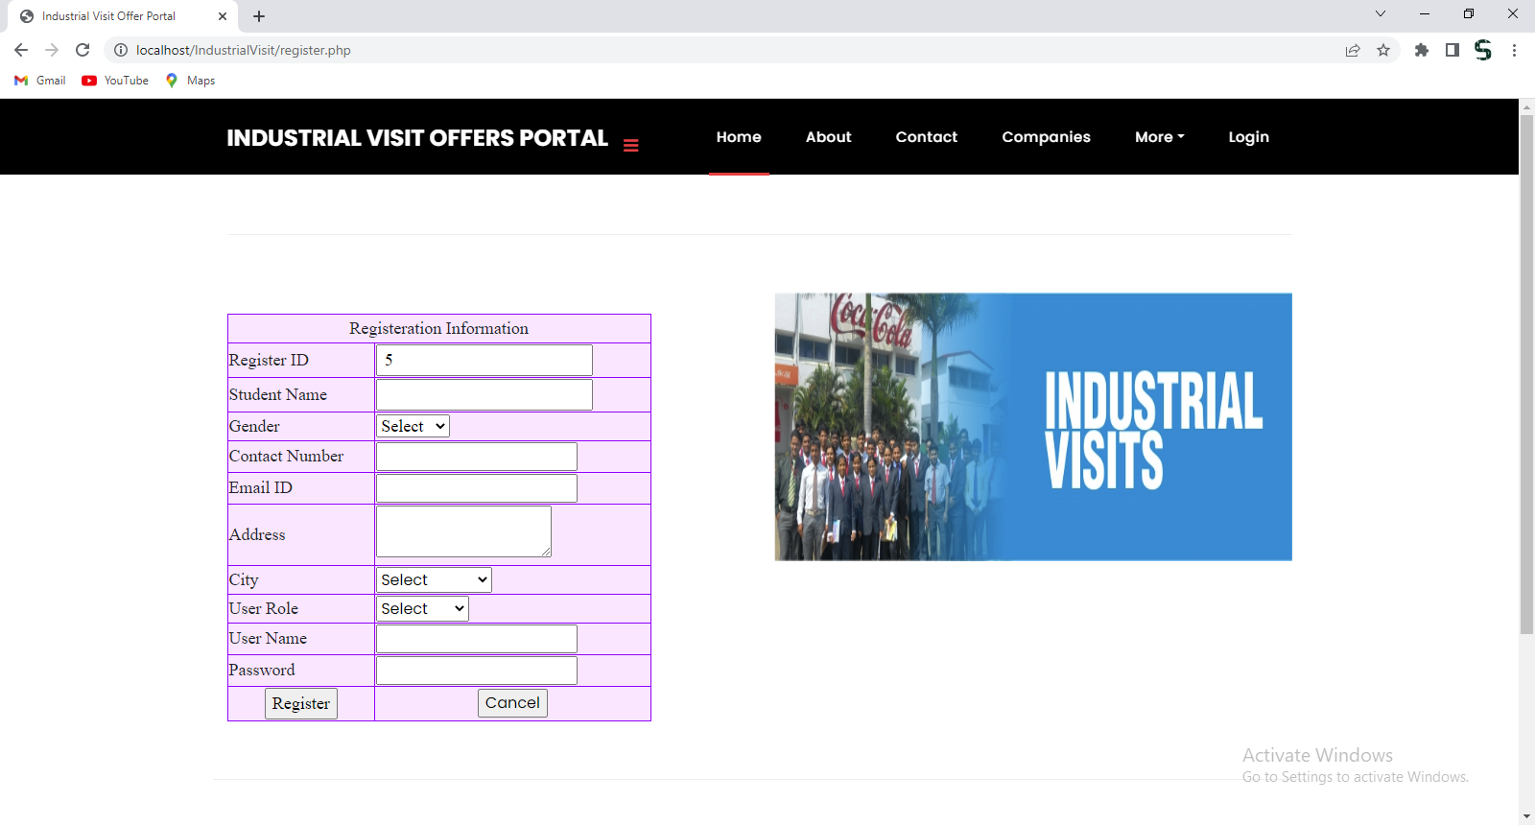

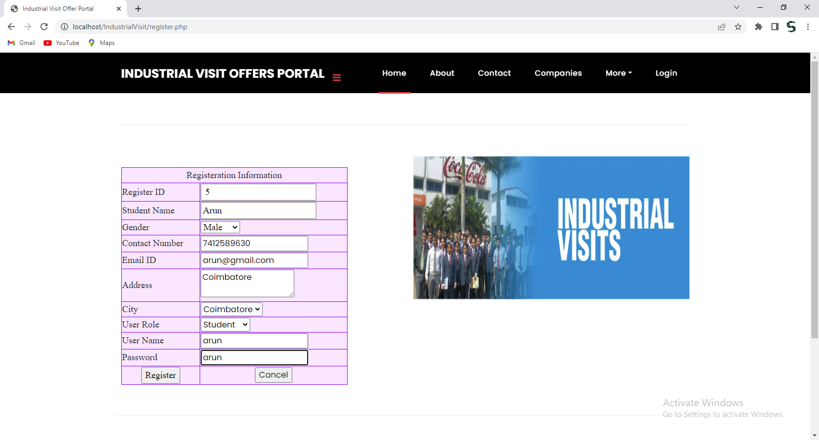

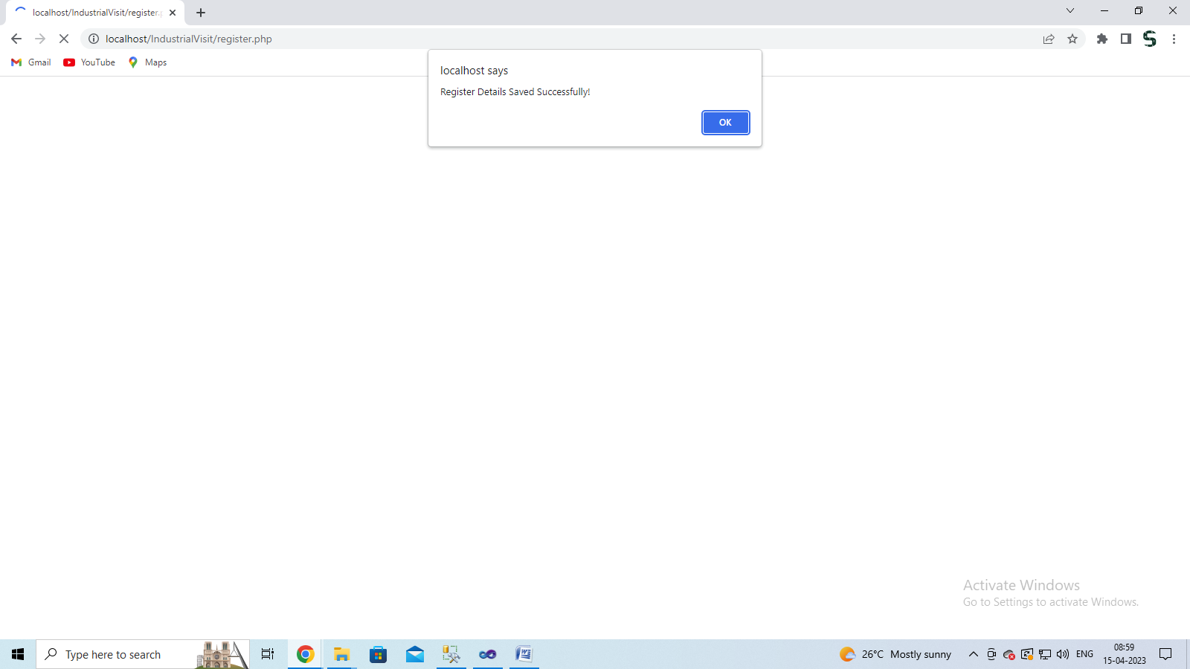

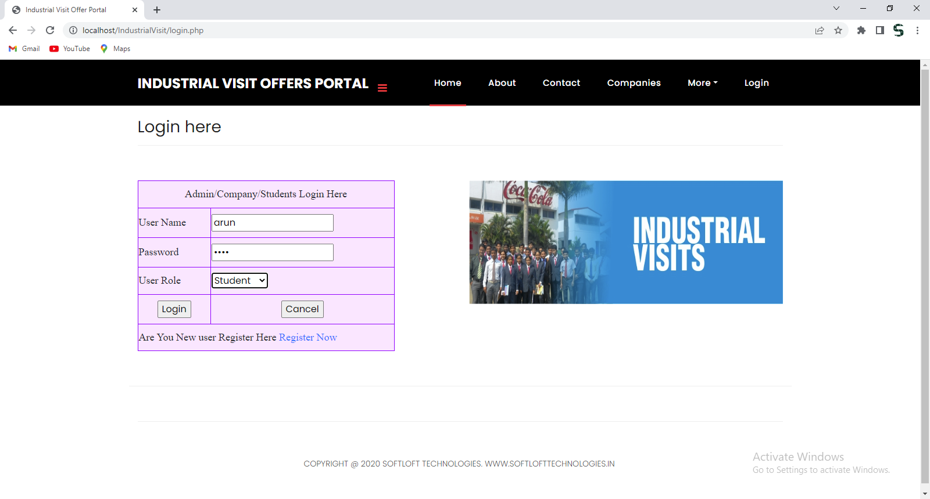

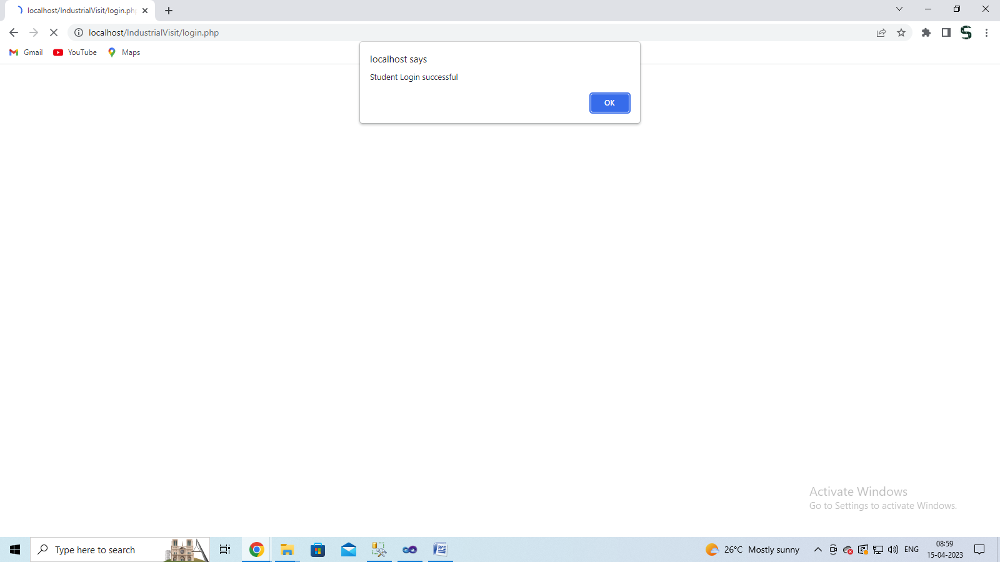

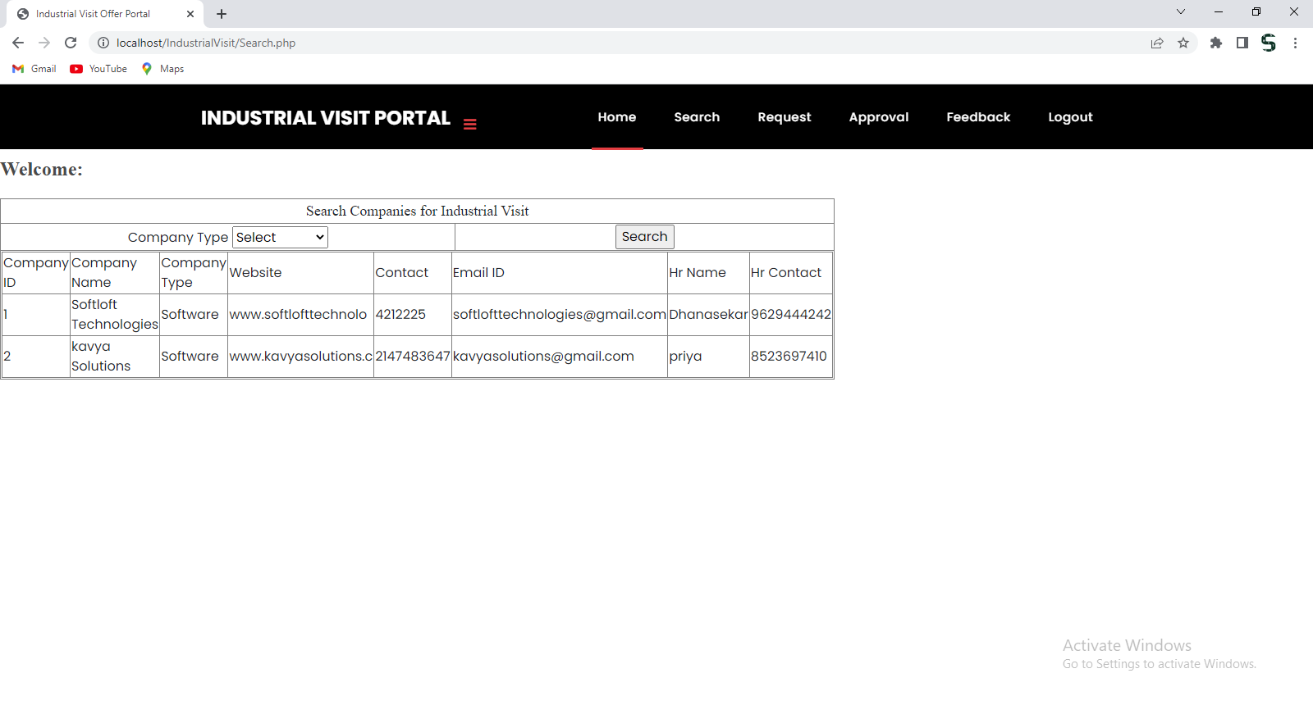

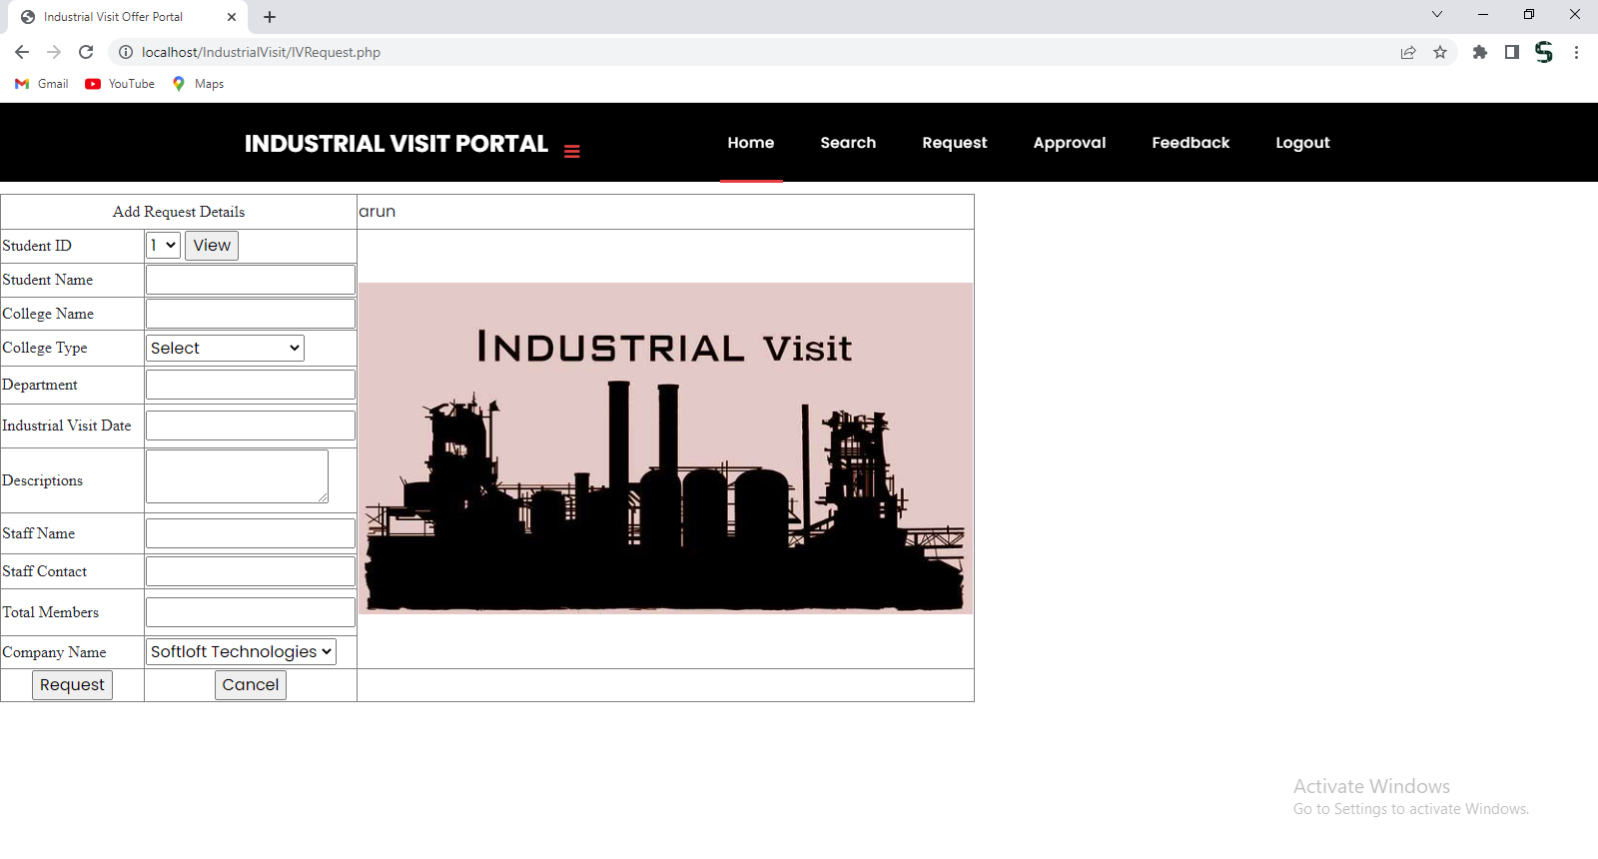

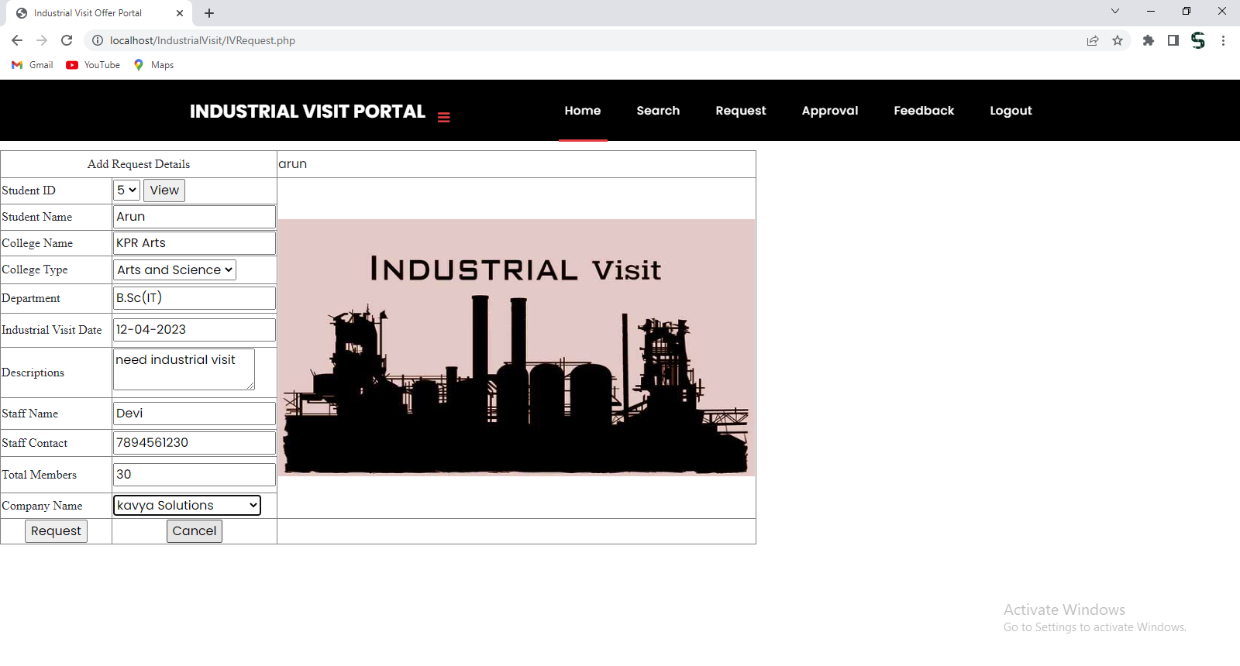

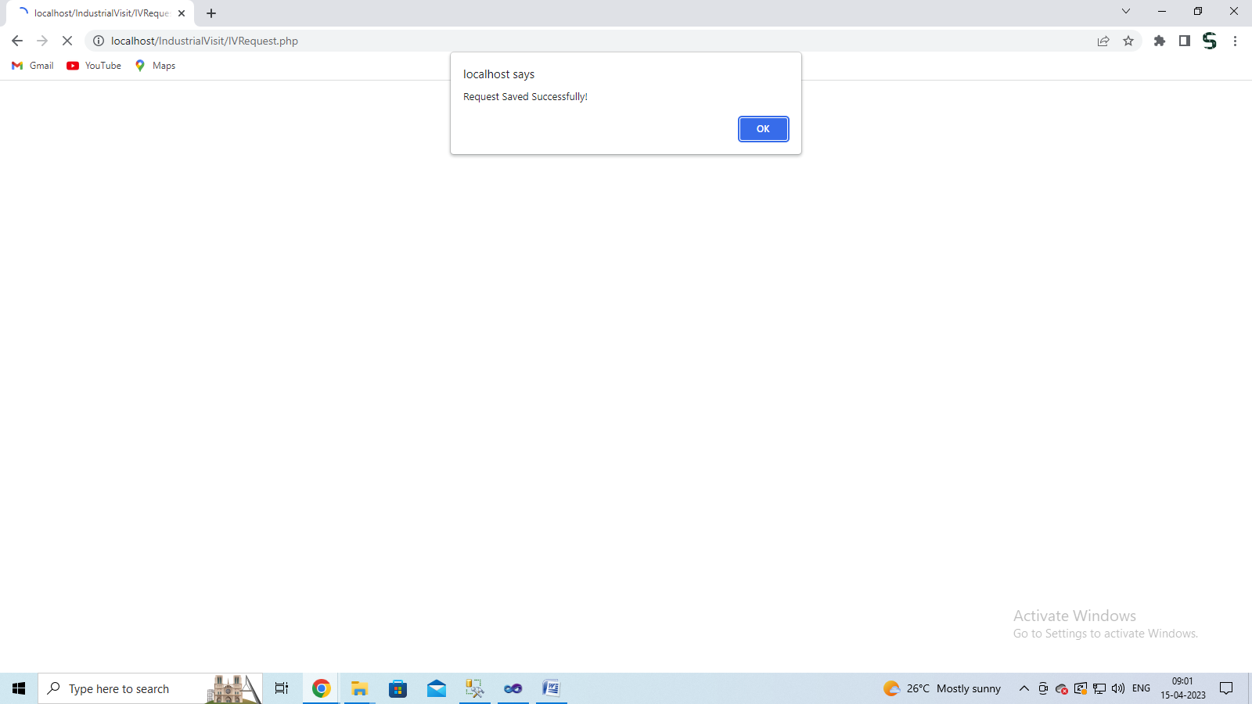

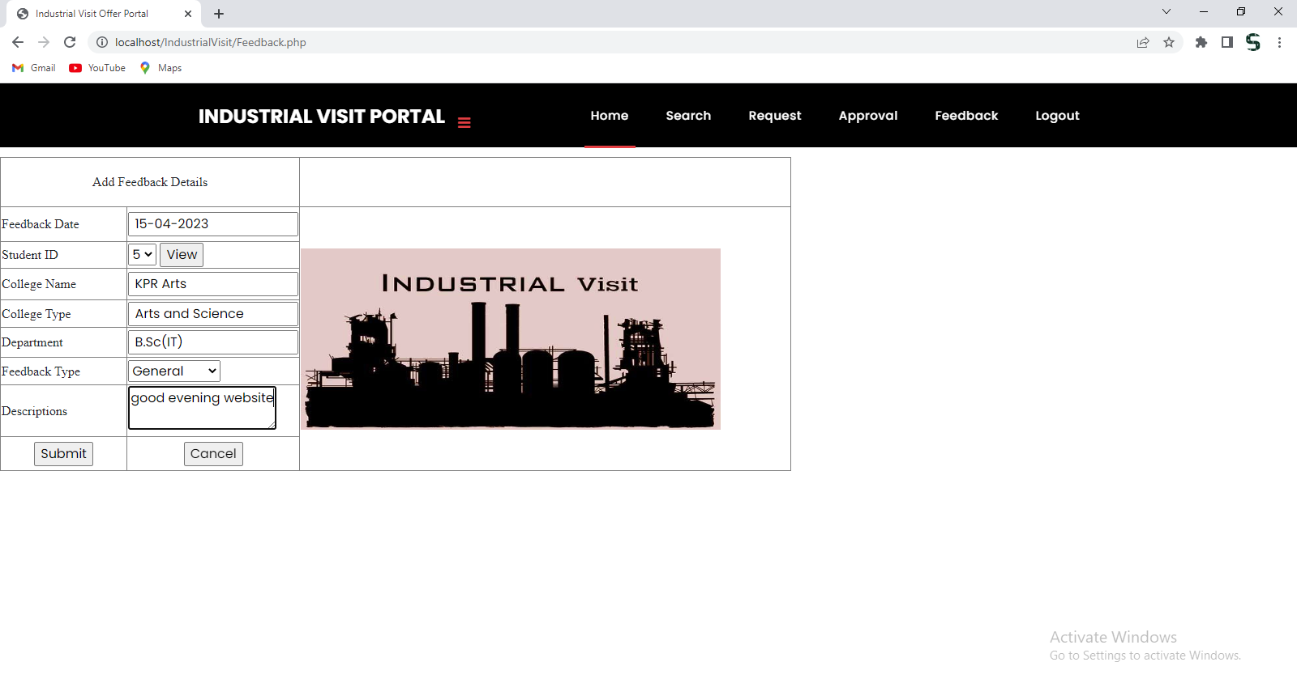

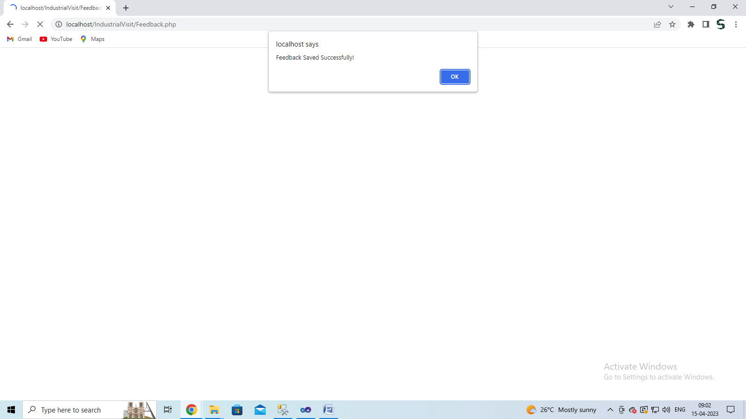

**Sample Coding**

<?php

session_start();

$servername = "localhost";

$Username = "root";

$password = "";

$dbname = "internship";

$nameErr="";

// Create connection

$conn = new mysqli($servername, $Username, $password, $dbname);

// Check connection

if ($conn->connect_error) {

die("Connection failed: " . $conn->connect_error);

}

$hostname="localhost";

$username="root";

$password="";

$db = "internship";

$dbh = new PDO("mysql:host=$hostname;dbname=$db", $username, $password);

foreach($dbh->query('SELECT MAX(registerid) FROM register') as $row)

{

$a1=$row['MAX(registerid)']+1;

}

if(isset($_REQUEST['Submit']))

{

$sql="INSERT INTO register VALUES ('$_POST[textfield]','$_POST[textfield2]','$_POST[select]','$_POST[textfield3]','$_POST[textfield4]','$_POST[textarea]','$_POST[select2]','$_POST[select3]','$_POST[textfield5]','$_POST[textfield6]')";

echo $sql;

if ($conn->query($sql) === TRUE)

{

$sql1="INSERT INTO login VALUES ('$_POST[textfield5]','$_POST[textfield6]','$_POST[select3]','$_POST[textfield]')";

if ($conn->query($sql1) === TRUE)

{

}

// echo "success";

echo '<script>alert("Register Details Saved Successfully!");</script>';

//$$URL="Register.php";

echo '<META HTTP-EQUIV="refresh" content="0;URL=' . $URL . '">';

echo "<script type='text/javascript'>document.location.href='{$URL}';</script>";

}

else

{

echo "Error: " . $sql . "<br>" . $conn->error;

}

}

if(isset($_REQUEST['Submit2']))

{

$_POST['username']="";

$_POST['password']="";

}

?>

<!DOCTYPE html>

<html lang="en">

<head>

<meta charset="utf-8">

<meta name="viewport" content="width=device-width, initial-scale=1, shrink-to-fit=no">

<meta name="description" content="">

<meta name="author" content="">

<link rel="icon" href="assets/images/favicon.ico">

<link href="https://fonts.googleapis.com/css?family=Poppins:100,200,300,400,500,600,700,800,900&display=swap" rel="stylesheet">

<title>Industrial Visit Offer Portal</title>

<!-- Bootstrap core CSS -->

<link href="vendor/bootstrap/css/bootstrap.min.css" rel="stylesheet">

<!-- Additional CSS Files -->

<link rel="stylesheet" href="assets/css/fontawesome.css">

<link rel="stylesheet" href="assets/css/style.css">

<link rel="stylesheet" href="assets/css/owl.css">

<style type="text/css">

<!--

.style8 {font-size: 18px}

.style3 {font-family: "Times New Roman", Times, serif; font-size: 18px; }

.style10 {font-family: "Times New Roman", Times, serif; font-size: 18; }

-->

</style>

</head>

<body>

<form id="form1" name="form1" method="post" action="">

<!-- ***** Preloader Start ***** -->

<div id="preloader">

<div class="jumper">

<div></div>

<div></div>

<div></div>

</div>

</div>

<!-- ***** Preloader End ***** -->

<!-- Header -->

<header class="">

<nav class="navbar navbar-expand-lg">

<div class="container">

<a class="navbar-brand" href="home.php"><h2>Industrial Visit Offers Portal</h2></a>

<span class="navbar-toggler-icon"></span> </button>

<div class="collapse navbar-collapse" id="navbarResponsive">

<ul class="navbar-nav ml-auto">

<li class="nav-item active">

<a class="nav-link" href="home.php">Home </a> </li>

<li class="nav-item"><a class="nav-link" href="about.php">About</a></li>

<li class="nav-item"><a class="nav-link" href="contact.php">Contact</a></li>

<li class="nav-item"><a class="nav-link" href="companies.php">Companies</a></li>

<li class="nav-item dropdown">

<a class="nav-link dropdown-toggle" data-toggle="dropdown" href="#" role="button" aria-haspopup="true" aria-expanded="false">More</a>

<div class="dropdown-menu">

<a class="dropdown-item" href="rules.php">Rules</a>

<a class="dropdown-item" href="offers.php">Offers</a> </div>

</li>

<li class="nav-item"><a class="nav-link" href="login.php">Login</a></li>

</ul>

</div>

</div>

</nav>

</header>

<!-- Page Content -->

<!-- Banner Starts Here -->

<div class="banner header-text">

<div class="owl-banner owl-carousel">

<div class="banner-item-01">

<div class="text-content">

<h4>Find your Best Offer Today</h4>

</div>

</div>

<div class="banner-item-02">

<div class="text-content">

<h4>Fugiat Aspernatur</h4>

<h2>Laboriosam reprehenderit ducimus</h2>

</div>

</div>

<div class="banner-item-03">

<div class="text-content">

<h4>Saepe Omnis</h4>

<h2>Quaerat suscipit unde minus dicta</h2>

</div>

</div>

</div>

</div>

<!-- Banner Ends Here -->

<div class="best-features">

<div class="container">

<div class="row">

<div class="col-md-12">

<div class="section-heading"></div>

</div>

<div class="col-md-6">

<div class="left-content">

<div class="active">

<h2 class="style8">&nbsp;</h2>

<table width="442" height="294" border="1" bordercolor="#9933FF" bgcolor="#FDE7FE">

<tr>

<td colspan="2"><div align="center" class="style3"><span class="style8">Registeration Information</span></div></td>

</tr>

<tr>

<td><span class="style3">Register ID </span></td>

<td><span class="style3">

<input type="text" name="textfield" value=" <?php echo $a1; ?>">

</span></td>

</tr>

<tr>

<td><span class="style3">Student Name </span></td>

<td><span class="style3">

<input type="text" name="textfield2">

</span></td>

</tr>

<tr>

<td><span class="style3">Gender</span></td>

<td><span class="style3">

<select name="select">

<option value="Select">Select</option>

<option value="Male">Male</option>

<option value="Female">Female</option>

<option value="Others">Others</option>

</select>

</span></td>

</tr>

<tr>

<td><span class="style3">Contact Number </span></td>

<td><input type="text" name="textfield3"></td>

</tr>

<tr>

<td><span class="style3">Email ID </span></td>

<td><input type="text" name="textfield4"></td>

</tr>

<tr>

<td><span class="style3">Address</span></td>

<td><textarea name="textarea"></textarea></td>

</tr>

<tr>

<td><span class="style3">City</span></td>

<td><select name="select2">

<option value="Select">Select</option>

<option value="Coimbatore">Coimbatore</option>

<option value="Tirupur">Tirupur</option>

<option value="Erode">Erode</option>

</select></td>

</tr>

<tr>

<td><span class="style3">User Role </span></td>

<td><select name="select3">

<option value="Select">Select</option>

<option value="Authority">Authority</option>

<option value="Student">Student</option>

</select></td>

</tr>

<tr>

<td class="style3"><span class="style10">User Name </span></td>

<td><input type="text" name="textfield5"></td>

</tr>

<tr>

<td class="style3"><span class="style10">Password</span></td>

<td><input type="text" name="textfield6"></td>

</tr>

<tr>

<td class="style3">

<div align="center">

<input type="submit" name="Submit" value="Register">

</div>

</td>

<td>

<div align="center">

<input type="submit" name="Submit2" value="Cancel">

</div>

</td>

</tr>

</table>

</div>

</div>

</div>

<div class="col-md-6">

<div class="right-image">

<img src="Images/1.jpg" alt="" width="844" height="280"> </div>

</div>

</div>

</div>

</div>

<div class="call-to-action">

<div class="container">

<div class="row"></div>

</div>

</div>

<footer>

<div class="container">

<div class="row">

<div class="col-md-12">

<div class="inner-content">

<p>Copyright @ 2020 SoftLoft Technologies. www.softlofttechnologies.in<a href="https://www.phpjabbers.com/"></a></p>

</div>

</div>

</div>

</div>

</footer>

<!-- Bootstrap core JavaScript -->

<script src="vendor/jquery/jquery.min.js"></script>

<script src="vendor/bootstrap/js/bootstrap.bundle.min.js"></script>

<!-- Additional Scripts -->

<script src="assets/js/custom.js"></script>

<script src="assets/js/owl.js"></script>

</form>

</body>

</html>

<?php

session_start();

$con = mysql_connect("localhost","root","");

$exe = mysql_select_db('Internship',$con);

$uri = $_SERVER["QUERY_STRING"];

//echo $uri;

if(isset($_REQUEST['Submit']))

{

$a1=$_POST['username'];

$a2=$_POST['password'];

echo $a1;

if (($_POST['textfield']=="Admin") and ($_POST['textfield2']=="Admin"))

{

@$_SESSION['username'] = $_REQUEST['username'];

echo '<script>alert("Admin Login successful");</script>';

$URL="AdminHome.php";

echo '<META HTTP-EQUIV="refresh" content="0;URL=' . $URL . '">';

echo "<script type='text/javascript'>document.location.href='{$URL}';</script>";

}

else if($_POST['select']=="Student")

{

$sel ="select * from login where username = '".$_POST['textfield']."' and password = '".$_POST['textfield2']."'

and role = '".$_POST['select']."' ";

$run = mysql_query($sel);

$getNo = mysql_num_rows($run);

if($getNo!='')

{

@$_SESSION['username'] = $_REQUEST['textfield'];

$getRecords = mysql_fetch_array($run);

echo '<script>alert("Student Login successful");</script>';

$URL="StudentHome.php";

echo '<META HTTP-EQUIV="refresh" content="0;URL=' . $URL . '">';

echo "<script type='text/javascript'>document.location.href='{$URL}';</script>";

}

else

{

echo '<script>alert("Invalid Student username and Password!");</script>';

}

}

else if($_POST['select']=="Authority")

{

$sel ="select * from login where username = '".$_POST['textfield']."' and password = '".$_POST['textfield2']."'

and role = '".$_POST['select']."' ";

$run = mysql_query($sel);

$getNo = mysql_num_rows($run);

if($getNo!='')

{

@$_SESSION['username'] = $_REQUEST['textfield'];

$getRecords = mysql_fetch_array($run);

echo '<script>alert("Authority Login successful");</script>';

$URL="CompanyHome.php";

echo '<META HTTP-EQUIV="refresh" content="0;URL=' . $URL . '">';

echo "<script type='text/javascript'>document.location.href='{$URL}';</script>";

}

else

{

echo '<script>alert("Invalid Staff username and Password!");</script>';

}

}

}

if(isset($_REQUEST['Submit2']))

{

$_POST['username']="";

$_POST['password']="";

}

?>

<!DOCTYPE html>

<html lang="en">

<head>

<meta charset="utf-8">

<meta name="viewport" content="width=device-width, initial-scale=1, shrink-to-fit=no">

<meta name="description" content="">

<meta name="author" content="">

<link rel="icon" href="assets/images/favicon.ico">

<link href="https://fonts.googleapis.com/css?family=Poppins:100,200,300,400,500,600,700,800,900&display=swap" rel="stylesheet">

<title>Industrial Visit Offer Portal</title>

<!-- Bootstrap core CSS -->

<link href="vendor/bootstrap/css/bootstrap.min.css" rel="stylesheet">

<!-- Additional CSS Files -->

<link rel="stylesheet" href="assets/css/fontawesome.css">

<link rel="stylesheet" href="assets/css/style.css">

<link rel="stylesheet" href="assets/css/owl.css">

<style type="text/css">

<!--

.style3 {font-family: "Times New Roman", Times, serif; font-size: 18px; }

-->

</style>

</head>

<body>

<form id="form1" name="form1" method="post" action="">

<!-- ***** Preloader Start ***** -->

<div id="preloader">

<div class="jumper">

<div></div>

<div></div>

<div></div>

</div>

</div>

<!-- ***** Preloader End ***** -->

<!-- Header -->

<header class="">

<nav class="navbar navbar-expand-lg">

<div class="container">

<a class="navbar-brand" href="home.php"><h2>Industrial Visit Offers Portal</h2></a>

<span class="navbar-toggler-icon"></span> </button>

<div class="collapse navbar-collapse" id="navbarResponsive">

<ul class="navbar-nav ml-auto">

<li class="nav-item active">

<a class="nav-link" href="home.php">Home </a> </li>

<li class="nav-item"><a class="nav-link" href="about.php">About</a></li>

<li class="nav-item"><a class="nav-link" href="contact.php">Contact</a></li>

<li class="nav-item"><a class="nav-link" href="companies.php">Companies</a></li>

<li class="nav-item dropdown">

<a class="nav-link dropdown-toggle" data-toggle="dropdown" href="#" role="button" aria-haspopup="true" aria-expanded="false">More</a>

<div class="dropdown-menu">

<a class="dropdown-item" href="rules.php">Rules</a>

</div>

</li>

<li class="nav-item"><a class="nav-link" href="login.php">Login</a></li>

</ul>

</div>

</div>

</nav>

</header>

<!-- Page Content -->

<div class="best-features">

<div class="container">

<div class="row">

<div class="col-md-12">

<div class="section-heading">

<h2>&nbsp;</h2>

<h2>Login here </h2>

</div>

</div>

<div class="col-md-6">

<div class="left-content">

<table width="442" height="294" border="1" bordercolor="#9933FF" bgcolor="#FDE7FE">

<tr>

<td colspan="2"><div align="center" class="style3">Admin/Company/Students Login Here </div></td>

</tr>

<tr>

<td><span class="style3">User Name </span></td>

<td>

<input type="text" name="textfield">

</td>

</tr>

<tr>

<td><span class="style3">Password</span></td>

<td>

<input type="password" name="textfield2">

</td>

</tr>

<tr>

<td><span class="style3">User Role </span></td>

<td>

<select name="select">

<option value="Select">Select</option>

<option value="Admin">Admin</option>

<option value="Authority">Authority</option>

<option value="Student">Student</option>

</select>

</td>

</tr>

<tr>

<td>

<div align="center">

<input type="submit" name="Submit" value="Login">

</div>

</td>

<td>

<div align="center">

<input type="submit" name="Submit2" value="Cancel">

</div>

</td>

</tr>

<tr>

<td colspan="2"><span class="style3">Are You New user Register Here <a href="register.php">Register Now</a></span></td>

</tr>

</table>

</div>

</div>

<div class="col-md-6">

<div class="right-image">

<img src="Images/1.jpg" alt="" width="74%" height="213"> </div>

</div>

</div>

</div>

</div>

<div class="call-to-action">

<div class="container">

<div class="row"></div>

</div>

</div>

<footer>

<div class="container">

<div class="row">

<div class="col-md-12">

<div class="inner-content">

<p>Copyright @ 2020 SoftLoft Technologies. www.softlofttechnologies.in<a href="https://www.phpjabbers.com/"></a></p>

</div>

</div>

</div>

</div>

</footer>

<!-- Bootstrap core JavaScript -->

<script src="vendor/jquery/jquery.min.js"></script>

<script src="vendor/bootstrap/js/bootstrap.bundle.min.js"></script>

<!-- Additional Scripts -->

<script src="assets/js/custom.js"></script>

<script src="assets/js/owl.js"></script>

</form>

</body>

</html>